Size Chart for all
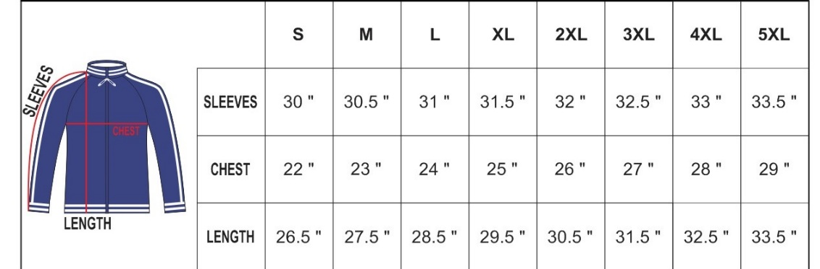
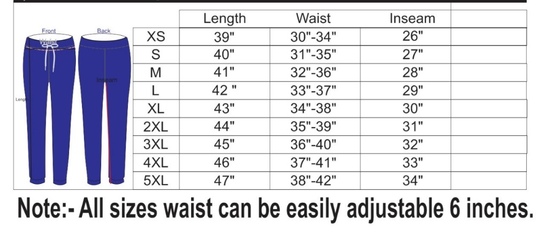

Wind Breaker
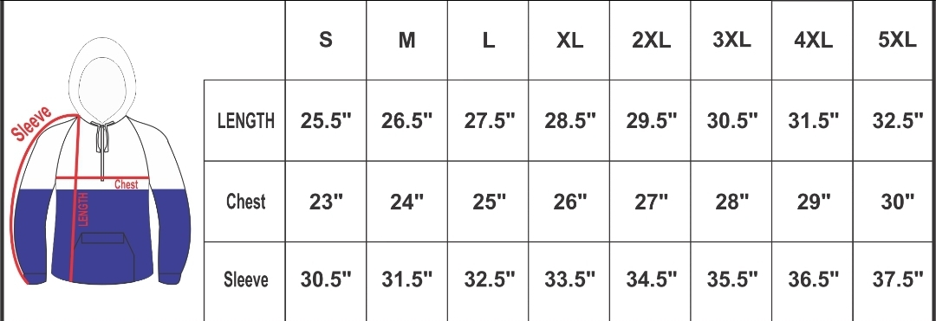

Sweatshirt
S M L XL 2XL 3XL
BODY WIDTH 20 22 24 26 28 30
FULL BODY LENGTH 26 27 28 29 30 31
SLEEVE LENGTH 33 34 35 36 37 38
T-Shirt
XS S M L XL 2XL 3XL 4XL
BODY WIDTH 16.5 18 20 22 24 26 28 30
FULL BODY LENGTH 27 28 29 30 31 32 33 34
SLEEVE LENGTH 8 8.25 8.63 9.13 9.63 10.25
Long sleeve Shirt
XS S M L XL 2XL
BODY WIDTH 16.5 18 20 22 24 26
FULL BODY LENGTH 27 28 29 30 31 32
SLEEVE LENGTH 25.63 26.25 26.88 27.5 28.13

